Chapter 12: Some Lessons from Capital Market History

Concept Questions

- Risk and Return: We have seen that over long periods, stock investments have tended to substantially outperform bond investments. However, it is common to observe investors with long horizons holding entirely bonds. Are such investors irrational?

No, stocks are riskier than bonds. Some investors are highly risk averse, and the extra possible return doesn’t attract them relative to the extra risk.

4. Market Efficiency Implications: Explain why a characteristic of an efficient market is that investments in that market have zero net present values (NPVs).

On average, the only return that is earned is the required return. Investors buy assets with returns in excess of the required return (i.e., positive NPV), bidding up the price and thus causing the return to fall to the required return (zero NPS). Investors sell assets with returns less than the required return (negative NPV) driving the price lower and thus causing the return to rise to the required return (zero NPV).

9. Efficient Market Hypothesis: Several celebrated investors and stock pickers frequently mentioned in the financial press have recorded huge returns on their investments over the past two decades. Is the success of these particular investors an invalidation of the EMH? Explain.

The EMH only says, within the bounds of increasingly strong assumptions about the information processing of investors, that assets are fairly priced. An implication of this is that, on average, the typical market participant cannot earn excessive profits from a particular trading strategy. However, that does not mean that a few particular investors cannot outperform the market over a particular investment horizon. Certain investors who do well for a period of time get a lot of attention from the financial press, but hundreds of investors who do not do well over the same period of time generally get considerably less attention from the press.

Problems

- Calculating Returns: Suppose you bought a 7 percent coupon bond one year ago for $1,040. The bond sells for $1,070 today.

- Assuming a $1,000 face value, what was your total dollar return on this investment over the past year?

The total dollar return is the change in price (capital gains or capital loss) plus the coupon payment:

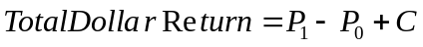

- What was your total nominal rate of return on this investment over the past year?

The total nominal rate of return can be found using the following equation:

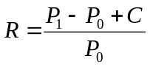

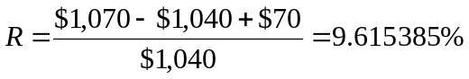

- If the inflation rate last year was 4 percent, what was your total real rate of return on this investment?

Using the Fisher equation, the real return is:

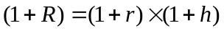 or 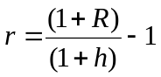

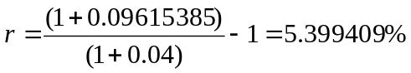

8. Risk Premiums: Refer to Table 12.1 in the text (page 375 in RWJ 9th edition) and look at the period from 1970 through 1975.

Large-Company T-bill
Year Stock Return Return
1970 3.94% 6.50%
1971 14.30 4.36
1972 18.99 4.23
1973 -14.69 7.29
1974 -26.47 7.99
1975 37.23 5.87

- Calculate the arithmetic average returns for large-company stocks and T-bills over this period.

To calculate the arithmetic average returns, sum up the returns for the 6 years and divide by 6:

Large-Company T-bill
Year Stock Return Return
1970 3.94% 6.50%
1971 14.30 4.36
1972 18.99 4.23
1973 -14.69 7.29
1974 -26.47 7.99
1975 37.23 5.87
Total 33.30 36.24

The average return for large company stocks over this period was:

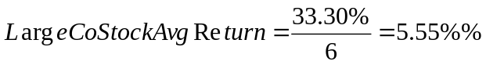

The average return for T-bills over this period was:

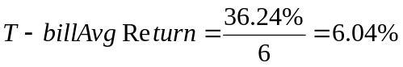

- Calculate the standard deviation of the returns for large-company stocks and T-bills over this period.

Using the equation for variance, we find the variance for large-company stocks’ returns over the period was:

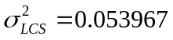

And the standard deviation for large-company stocks’ returns over the period was:

Using the equation for variance, we find the variance for T-bills’ returns over the period was:

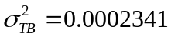

And the standard deviation for T-bills’ returns over the period was:

- Calculate the observed risk premium in each year for the large-company stocks versus the T-bills. What was the average risk premium over this period? What was the standard deviation of the risk premium over this period?

The risk premium for large-company stocks is the return on large-company stocks minus T-bill returns for each year:

Large-Company T-bill Risk
Year Stock Return Return Premium
1970 3.94% 6.50% -2.56%
1971 14.30 4.36 9.94
1972 18.99 4.23 14.76
1973 -14.69 7.29 -21.98
1974 -26.47 7.99 -34.46
1975 37.23 5.87 31.36
Total 33.30 36.24 -2.94

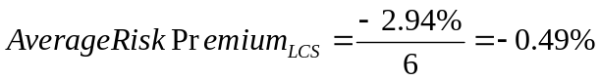

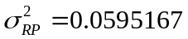

- Is it possible for the risk premium to be negative before an investment is undertaken? Can the risk premium be negative after the fact? Explain.

Before the fact, for most assets the risk premium will be positive since investors will demand compensation over and above the risk-free return to invest money in risky assets. After the fact, the observed risk premium can be negative if the asset’s nominal return is unexpectedly low, the risk-free return is unexpectedly high, or if some combination of these two events occurs.

- Arithmetic and Geometric Values: A stock has had the following year-end prices and dividends:

Year Price Dividend
0 $60.18
1 73.66 $0.60
2 94.18 0.64
3 89.35 0.72
4 78.49 0.80
5 95.05 1.20

What are the arithmetic and geometric returns for the stock?

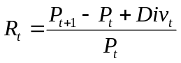

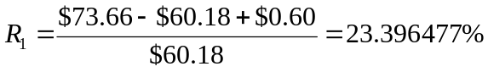

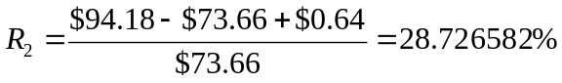

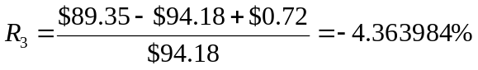

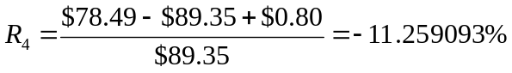

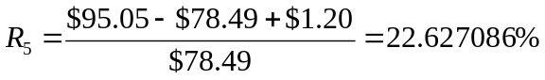

The arithmetic average is:

The geometric average is:

